**Introduction to chinook SQLite sample database**

We provide you with the SQLite sample database named chinook.

The following database diagram illustrates the chinook database tables and their relationships.

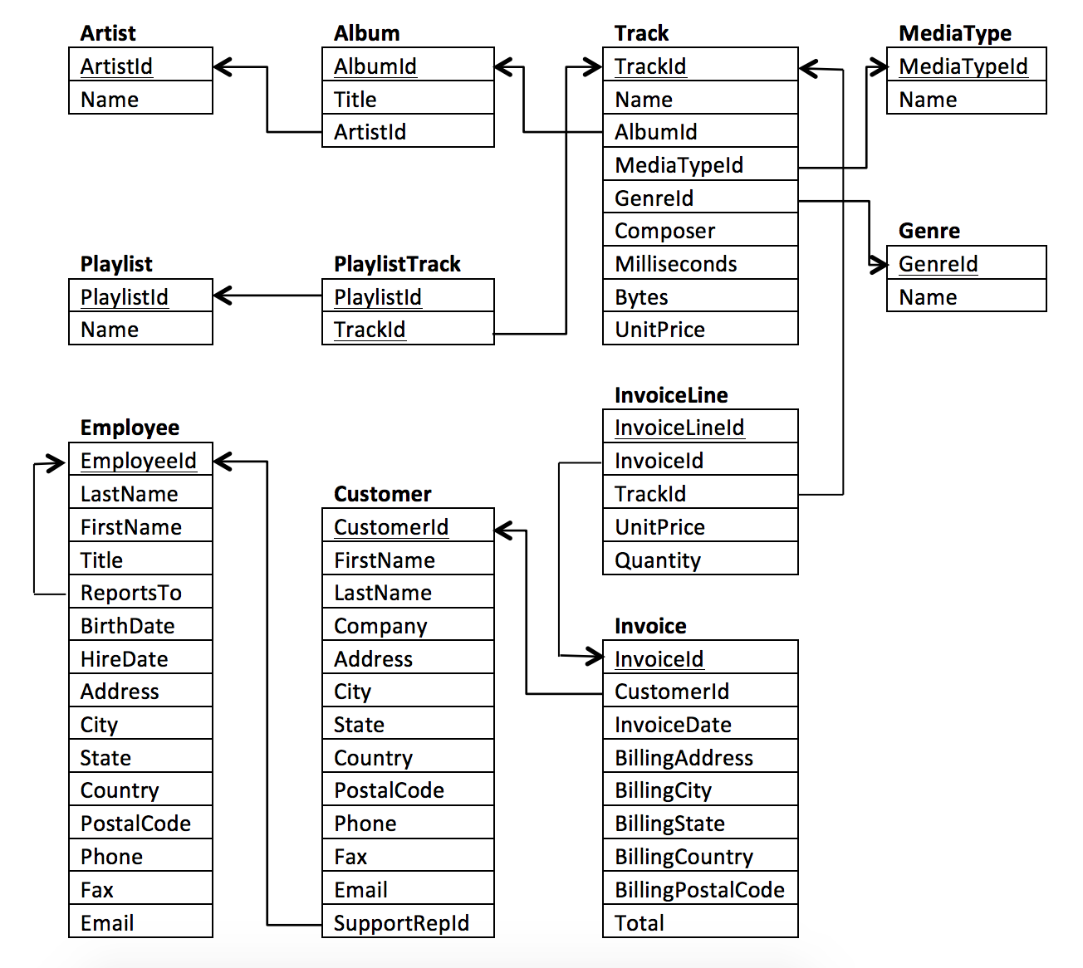

**Chinook sample database tables**

There are 11 tables in the chinook sample database.

* employees table stores employees data such as employee id, last name, first name, etc. It also has a field named ReportsTo to specify who reports to whom.
* customers table stores customers data.
* invoices & invoice_items tables: these two tables store invoice data. The invoices table stores invoice header data and the invoice_items table stores the invoice line items data.
* artists table stores artists data. It is a simple table that contains only the artist id and name.
* albums table stores data about a list of tracks. Each album belongs to one artist. However, one artist may have multiple albums.
* media_types table stores media types such as MPEG audio and AAC audio files.
* genres table stores music types such as rock, jazz, metal, etc.
* tracks table stores the data of songs. Each track belongs to one album.
* playlists & playlist_track tables: playlists table store data about playlists. Each playlist contains a list of tracks. Each track may belong to multiple playlists. The relationship between the playlists table and tracks table is many-to-many. The playlist_track table is used to reflect this relationship.